Ex.no:4b | EXPLORATORY DATA ANALYSIS (EDA) – DATA INSPECTION, FILTERING, STATISTICAL ANALYSIS AND CORRELATION

AIM
To perform data inspection, filtering, sorting, grouping, aggregation, descriptive statistical analysis, and correlation analysis on the Hotel Booking Demand, Customer Behavior and Cancellation Analysis dataset using Pandas, and to visualize the analytical results using Matplotlib.

ALGORITHM
Algorithm 1: Dataset Inspection
- Import the Hotel Booking Demand dataset.
- Display the first few records of the dataset.
- Check the dimensions of the dataset.
- Display the data types of the attributes.
- Generate a statistical summary of the numerical attributes.
Algorithm 2: Filtering Data
- Select the required attribute.
- Specify a suitable filtering condition.
- Apply the condition to the dataset.
- Display the filtered records.
Algorithm 3: Sorting Data
- Select the attribute to be sorted.
- Apply the sort_values() function.
- Specify the sorting order.
- Display the sorted dataset.
Algorithm 4: Statistical Analysis
- Select the required numerical attribute.
- Calculate the mean.
- Calculate the median.
- Calculate the mode.
- Calculate the standard deviation.
- Display the calculated statistical measures.
Algorithm 5: Grouping and Aggregation
- Select a categorical attribute such as hotel or market segment.
- Apply the groupby() function.
- Select the required numerical attribute.
- Calculate an aggregate measure such as mean or sum.
- Display the grouped results.
Algorithm 6: Correlation Analysis
- Select the required numerical attributes.
- Apply the corr() function.
- Generate the correlation matrix.
- Analyze the correlation coefficient between the selected attributes.
- Visualize the relationship using an appropriate graph.

CODE
import kagglehub
import pandas as pd
import numpy as np
import matplotlib.pyplot as plt
import seaborn as sns
import os

# ============================================================
# LOAD DATASET FROM KAGGLE
# ============================================================

path = kagglehub.dataset_download("jessemostipak/hotel-booking-demand")

print("Dataset Path:")
print(path)

# Find CSV file automatically
csv_files = [f for f in os.listdir(path) if f.endswith(".csv")]

print("\nCSV Files Found:")
print(csv_files)

csv_file = csv_files[0]

# Load Dataset
df = pd.read_csv(
os.path.join(path, csv_file),
encoding="latin1",
low_memory=False
)

print("\nDataset Loaded Successfully")

# ============================================================
# PROGRAM 1 - DATA INSPECTION
# ============================================================

print("\nFirst 5 Records")
print(df.head())

print("\nLast 5 Records")
print(df.tail())

# ============================================================
# PROGRAM 2 - SHAPE
# ============================================================

print("\nShape of Dataset")
print(df.shape)

print("\nRows =", df.shape[0])
print("Columns =", df.shape[1])

# ============================================================
# PROGRAM 3 - DATA TYPES
# ============================================================

print("\nData Types")
print(df.dtypes)

print("\nDataset Info")
df.info()

# ============================================================
# PROGRAM 4 - FILTERING
# Bookings with Lead Time > 100 Days
# ============================================================

long_lead = df[df["lead_time"] > 100]

print("\nBookings with Lead Time Greater Than 100 Days")

print(
long_lead[
[
"hotel",
"is_canceled",
"lead_time",
"arrival_date_year",
"market_segment",
"customer_type"
]
].head(10)
)

# ============================================================
# PROGRAM 5 - FILTER CANCELED BOOKINGS
# ============================================================

canceled = df[df["is_canceled"] == 1]

print("\nCanceled Bookings")

print(
canceled[
[
"hotel",
"is_canceled",
"lead_time",
"market_segment",
"customer_type"
]
].head(10)
)

# ============================================================
# PROGRAM 6 - SORTING
# Sort by Average Daily Rate
# ============================================================

sorted_df = df.sort_values(
by="adr",
ascending=False
)

print("\nTop Bookings by Average Daily Rate")

print(
sorted_df[
[
"hotel",
"arrival_date_year",
"market_segment",
"customer_type",
"adr",
"is_canceled"
]
].head(10)
)

# ============================================================
# BAR CHART
# TOP 10 BOOKINGS BY ADR
# ============================================================

top10 = sorted_df.head(10)

plt.figure(figsize=(10, 5))

plt.bar(
range(len(top10)),
top10["adr"]
)

plt.xticks(
range(len(top10)),
top10["hotel"],
rotation=90
)

plt.xlabel("Hotel")
plt.ylabel("Average Daily Rate (ADR)")
plt.title("Top 10 Hotel Bookings by ADR")

plt.show()

# ============================================================
# PROGRAM 7 - STATISTICAL ANALYSIS
# ============================================================

print("\nMean ADR =")
print(df["adr"].mean())

print("\nMedian ADR =")
print(df["adr"].median())

print("\nMode ADR =")
print(df["adr"].mode())

print("\nStandard Deviation =")
print(df["adr"].std())

print("\nMinimum ADR =")
print(df["adr"].min())

print("\nMaximum ADR =")
print(df["adr"].max())

# ============================================================
# PROGRAM 8 - DESCRIPTIVE STATISTICS
# ============================================================

print("\nDescriptive Statistics")

print(
df[
[
"lead_time",
"stays_in_weekend_nights",
"stays_in_week_nights",
"adults",
"children",
"babies",
"adr"
]
].describe()
)

# ============================================================
# PROGRAM 9 - GROUPING
# Average ADR by Hotel Type
# ============================================================

group = df.groupby(
"hotel"
)["adr"].mean().sort_values(ascending=False)

print("\nAverage ADR by Hotel Type")
print(group)

# Visualization

group.plot(
kind="bar",
figsize=(8, 5)
)

plt.xlabel("Hotel Type")
plt.ylabel("Average ADR")
plt.title("Average ADR by Hotel Type")

plt.xticks(rotation=0)

plt.show()

# ============================================================
# PROGRAM 10 - AGGREGATION
# ============================================================

summary = df.groupby("hotel").agg({
"adr": "mean",
"lead_time": "mean",
"is_canceled": "mean"
})

print("\nHotel Aggregation")
print(summary)

# ============================================================
# PROGRAM 11 - CORRELATION
# ============================================================

numeric = df.select_dtypes(
include=np.number
)

corr = numeric.corr()

print("\nCorrelation Matrix")
print(corr)

plt.figure(figsize=(12, 8))

sns.heatmap(
corr,
annot=False,
cmap="coolwarm"
)

plt.title("Hotel Booking Dataset Correlation Heatmap")

plt.show()

# ============================================================
# PROGRAM 12 - SCATTER PLOT
# Lead Time vs ADR
# ============================================================

plt.figure(figsize=(7, 5))

plt.scatter(
df["lead_time"],
df["adr"]
)

plt.xlabel("Lead Time")
plt.ylabel("Average Daily Rate (ADR)")
plt.title("Lead Time vs Average Daily Rate")

plt.show()

# ============================================================
# PROGRAM 13 - HISTOGRAM
# ADR Distribution
# ============================================================

plt.figure(figsize=(7, 5))

plt.hist(
df["adr"].dropna(),
bins=30
)

plt.xlabel("Average Daily Rate (ADR)")
plt.ylabel("Frequency")
plt.title("Distribution of Hotel Booking ADR")

plt.show()

# ============================================================
# PROGRAM 14 - BOXPLOT
# ============================================================

plt.figure(figsize=(7, 5))

sns.boxplot(
x=df["adr"].dropna()
)

plt.title("ADR Boxplot")
plt.xlabel("Average Daily Rate (ADR)")

plt.show()

# ============================================================
# PROGRAM 15 - VALUE COUNTS
# ============================================================

print("\nMarket Segment Counts")

print(
df["market_segment"].value_counts()
)

# ============================================================
# PROGRAM 16 - UNIQUE VALUES
# ============================================================

print("\nUnique Hotels")

print(
df["hotel"].unique()
)

print("\nUnique Market Segments")

print(
df["market_segment"].unique()
)

print("\nUnique Customer Types")

print(
df["customer_type"].unique()
)

# ============================================================
# PROGRAM 17 - TOP 10 COUNTRIES BY BOOKINGS
# ============================================================

print("\nTop 10 Countries by Number of Bookings")

country_counts = (
df["country"]
.value_counts()
.head(10)
)

print(country_counts)

# ============================================================
# PROGRAM 18 - BOOKINGS BY YEAR
# ============================================================

print("\nNumber of Bookings by Year")

year_counts = (
df["arrival_date_year"]
.value_counts()
.sort_index()
)

print(year_counts)

# ============================================================
# PROGRAM 19 - TOP 10 COUNTRIES BY CANCELLATIONS
# ============================================================

print("\nTop 10 Countries by Canceled Bookings")

country_cancellations = (
df[df["is_canceled"] == 1]
.groupby("country")
.size()
.sort_values(ascending=False)
.head(10)
)

print(country_cancellations)

# ============================================================
# PROGRAM 20 - MOST COMMON MARKET SEGMENTS
# ============================================================

print("\nMost Common Market Segments")

market_segments = (
df["market_segment"]
.value_counts()
.head(10)
)

print(market_segments)

# ============================================================
# PROGRAM 21 - EXPORT DATA
# ============================================================

df.to_csv(
"hotel_booking_data.csv",
index=False
)

df.to_excel(
"hotel_booking_data.xlsx",
index=False
)

df.to_json(
"hotel_booking_data.json",
orient="records",
indent=4
)

print("\nCSV, Excel and JSON files exported successfully.")

# ============================================================
# FINAL REPORT
# ============================================================

print("\n==============================================")
print("EXPERIMENT COMPLETED SUCCESSFULLY")
print("==============================================")

print("Dataset Shape :", df.shape)

print(
"Missing Values :",
df.isnull().sum().sum()
)

print(
"Total Bookings :",
len(df)
)

print(
"Total Canceled Bookings :",
df["is_canceled"].sum()
)

print(
"Average ADR :",
df["adr"].mean()
)

print(
"Number of Countries :",
df["country"].nunique()
)

print(
"Number of Market Segments :",
df["market_segment"].nunique()
)

print(
"Number of Customer Types :",
df["customer_type"].nunique()
)

print("Correlation Matrix Generated")

print("==============================================")
OUTPUT:
Dataset Loaded Successfully

First 5 Records
hotel is_canceled lead_time arrival_date_year arrival_date_month \
0 Resort Hotel 0 342 2015 July
1 Resort Hotel 0 737 2015 July
2 Resort Hotel 0 7 2015 July
3 Resort Hotel 0 13 2015 July
4 Resort Hotel 0 14 2015 July

arrival_date_week_number arrival_date_day_of_month \
0 27 1
1 27 1
2 27 1
3 27 1
4 27 1

stays_in_weekend_nights stays_in_week_nights adults ... deposit_type \
0 0 0 2 ... No Deposit
1 0 0 2 ... No Deposit
2 0 1 1 ... No Deposit
3 0 1 1 ... No Deposit
4 0 2 2 ... No Deposit

agent company days_in_waiting_list customer_type adr \
0 NaN NaN 0 Transient 0.0
1 NaN NaN 0 Transient 0.0
2 NaN NaN 0 Transient 75.0
3 304.0 NaN 0 Transient 75.0
4 240.0 NaN 0 Transient 98.0

required_car_parking_spaces total_of_special_requests reservation_status \
0 0 0 Check-Out
1 0 0 Check-Out
2 0 0 Check-Out
3 0 0 Check-Out
4 0 1 Check-Out

reservation_status_date
0 2015-07-01
1 2015-07-01
2 2015-07-02
3 2015-07-02
4 2015-07-03

[5 rows x 32 columns]

Last 5 Records
hotel is_canceled lead_time arrival_date_year \
119385 City Hotel 0 23 2017
119386 City Hotel 0 102 2017
119387 City Hotel 0 34 2017
119388 City Hotel 0 109 2017
119389 City Hotel 0 205 2017

arrival_date_month arrival_date_week_number \
119385 August 35
119386 August 35
119387 August 35
119388 August 35
119389 August 35

arrival_date_day_of_month stays_in_weekend_nights \
119385 30 2
119386 31 2
119387 31 2
119388 31 2
119389 29 2

stays_in_week_nights adults ... deposit_type agent company \
119385 5 2 ... No Deposit 394.0 NaN
119386 5 3 ... No Deposit 9.0 NaN
119387 5 2 ... No Deposit 9.0 NaN
119388 5 2 ... No Deposit 89.0 NaN
119389 7 2 ... No Deposit 9.0 NaN

days_in_waiting_list customer_type adr \
119385 0 Transient 96.14
119386 0 Transient 225.43
119387 0 Transient 157.71
119388 0 Transient 104.40
119389 0 Transient 151.20

required_car_parking_spaces total_of_special_requests \
119385 0 0
119386 0 2
119387 0 4
119388 0 0
119389 0 2

reservation_status reservation_status_date
119385 Check-Out 2017-09-06
119386 Check-Out 2017-09-07
119387 Check-Out 2017-09-07
119388 Check-Out 2017-09-07
119389 Check-Out 2017-09-07

[5 rows x 32 columns]

Shape of Dataset
(119390, 32)

Rows = 119390
Columns = 32

Data Types
hotel object
is_canceled int64
lead_time int64
arrival_date_year int64
arrival_date_month object
arrival_date_week_number int64
arrival_date_day_of_month int64
stays_in_weekend_nights int64
stays_in_week_nights int64
adults int64
children float64
babies int64
meal object
country object
market_segment object
distribution_channel object
is_repeated_guest int64
previous_cancellations int64
previous_bookings_not_canceled int64
reserved_room_type object
assigned_room_type object
booking_changes int64
deposit_type object
agent float64
company float64
days_in_waiting_list int64
customer_type object
adr float64
required_car_parking_spaces int64
total_of_special_requests int64
reservation_status object
reservation_status_date object
dtype: object

Dataset Info
<class 'pandas.core.frame.DataFrame'>
RangeIndex: 119390 entries, 0 to 119389
Data columns (total 32 columns):
# Column Non-Null Count Dtype
--- ------ -------------- -----
0 hotel 119390 non-null object
1 is_canceled 119390 non-null int64
2 lead_time 119390 non-null int64
3 arrival_date_year 119390 non-null int64
4 arrival_date_month 119390 non-null object
5 arrival_date_week_number 119390 non-null int64
6 arrival_date_day_of_month 119390 non-null int64
7 stays_in_weekend_nights 119390 non-null int64
8 stays_in_week_nights 119390 non-null int64
9 adults 119390 non-null int64
10 children 119386 non-null float64
11 babies 119390 non-null int64
12 meal 119390 non-null object
13 country 118902 non-null object
14 market_segment 119390 non-null object
15 distribution_channel 119390 non-null object
16 is_repeated_guest 119390 non-null int64
17 previous_cancellations 119390 non-null int64
18 previous_bookings_not_canceled 119390 non-null int64
19 reserved_room_type 119390 non-null object
20 assigned_room_type 119390 non-null object
21 booking_changes 119390 non-null int64
22 deposit_type 119390 non-null object
23 agent 103050 non-null float64
24 company 6797 non-null float64
25 days_in_waiting_list 119390 non-null int64
26 customer_type 119390 non-null object
27 adr 119390 non-null float64
28 required_car_parking_spaces 119390 non-null int64
29 total_of_special_requests 119390 non-null int64
30 reservation_status 119390 non-null object
31 reservation_status_date 119390 non-null object
dtypes: float64(4), int64(16), object(12)
memory usage: 29.1+ MB

Bookings with Lead Time Greater Than 100 Days
hotel is_canceled lead_time arrival_date_year market_segment \
0 Resort Hotel 0 342 2015 Direct
1 Resort Hotel 0 737 2015 Direct
24 Resort Hotel 0 127 2015 Offline TA/TO
30 Resort Hotel 0 118 2015 Direct
44 Resort Hotel 0 107 2015 Online TA
47 Resort Hotel 0 113 2015 Offline TA/TO
50 Resort Hotel 0 113 2015 Offline TA/TO
71 Resort Hotel 1 101 2015 Online TA
81 Resort Hotel 1 368 2015 Offline TA/TO
82 Resort Hotel 0 364 2015 Offline TA/TO

customer_type
0 Transient
1 Transient
24 Contract
30 Transient
44 Transient
47 Transient-Party
50 Transient-Party
71 Transient
81 Contract
82 Contract

Canceled Bookings
hotel is_canceled lead_time market_segment customer_type
8 Resort Hotel 1 85 Online TA Transient
9 Resort Hotel 1 75 Offline TA/TO Transient
10 Resort Hotel 1 23 Online TA Transient
27 Resort Hotel 1 60 Online TA Transient
32 Resort Hotel 1 96 Direct Transient
34 Resort Hotel 1 45 Online TA Transient
35 Resort Hotel 1 40 Online TA Transient
38 Resort Hotel 1 43 Online TA Transient
40 Resort Hotel 1 45 Online TA Transient
45 Resort Hotel 1 47 Online TA Transient

Top Bookings by Average Daily Rate
hotel arrival_date_year market_segment customer_type \
48515 City Hotel 2016 Offline TA/TO Transient
111403 City Hotel 2017 Offline TA/TO Transient
15083 Resort Hotel 2015 Corporate Transient
103912 City Hotel 2016 Direct Transient-Party
13142 Resort Hotel 2017 Online TA Transient
13391 Resort Hotel 2017 Direct Transient
39155 Resort Hotel 2017 Direct Transient
39568 Resort Hotel 2017 Online TA Transient
39118 Resort Hotel 2017 Direct Transient
13323 Resort Hotel 2017 Direct Transient

adr is_canceled
48515 5400.00 1
111403 510.00 0
15083 508.00 0
103912 451.50 0
13142 450.00 1
13391 437.00 1

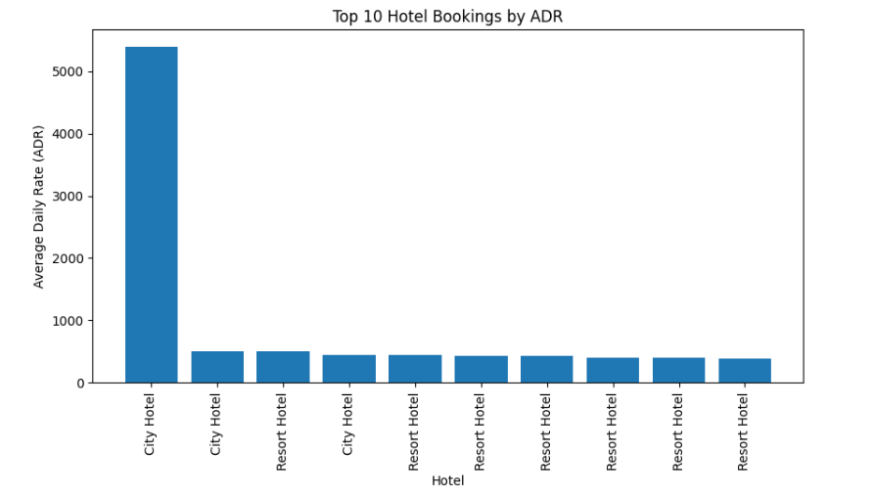
Mean ADR =
101.83112153446686

Median ADR =
94.575

Mode ADR =
0 62.0
Name: adr, dtype: float64

Standard Deviation =
50.5357902855456

Minimum ADR =
-6.38

Maximum ADR =
5400.0

Descriptive Statistics
lead_time stays_in_weekend_nights stays_in_week_nights \
count 119390.000000 119390.000000 119390.000000
mean 104.011416 0.927599 2.500302
std 106.863097 0.998613 1.908286
min 0.000000 0.000000 0.000000
25% 18.000000 0.000000 1.000000
50% 69.000000 1.000000 2.000000
75% 160.000000 2.000000 3.000000
max 737.000000 19.000000 50.000000

adults children babies adr
count 119390.000000 119386.000000 119390.000000 119390.000000
mean 1.856403 0.103890 0.007949 101.831122
std 0.579261 0.398561 0.097436 50.535790
min 0.000000 0.000000 0.000000 -6.380000
25% 2.000000 0.000000 0.000000 69.290000
50% 2.000000 0.000000 0.000000 94.575000
75% 2.000000 0.000000 0.000000 126.000000
max 55.000000 10.000000 10.000000 5400.000000

Average ADR by Hotel Type
hotel
City Hotel 105.304465
Resort Hotel 94.952930
Name: adr, dtype: float64
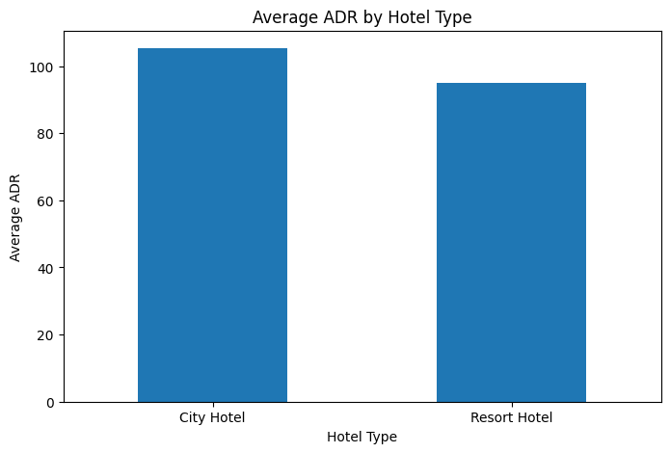

Hotel Aggregation
adr lead_time is_canceled
hotel
City Hotel 105.304465 109.735724 0.417270
Resort Hotel 94.952930 92.675686 0.277634

Correlation Matrix
is_canceled lead_time arrival_date_year \
is_canceled 1.000000 0.293123 0.016660
lead_time 0.293123 1.000000 0.040142
arrival_date_year 0.016660 0.040142 1.000000
arrival_date_week_number 0.008148 0.126871 -0.540561
arrival_date_day_of_month -0.006130 0.002268 -0.000221
stays_in_weekend_nights -0.001791 0.085671 0.021497
stays_in_week_nights 0.024765 0.165799 0.030883
adults 0.060017 0.119519 0.029635
children 0.005048 -0.037622 0.054624
babies -0.032491 -0.020915 -0.013192
is_repeated_guest -0.084793 -0.124410 0.010341
previous_cancellations 0.110133 0.086042 -0.119822
previous_bookings_not_canceled -0.057358 -0.073548 0.029218
booking_changes -0.144381 0.000149 0.030872
agent -0.083114 -0.069741 0.063457
company -0.020642 0.151464 0.259095
days_in_waiting_list 0.054186 0.170084 -0.056497
adr 0.047557 -0.063077 0.197580
required_car_parking_spaces -0.195498 -0.116451 -0.013684
total_of_special_requests -0.234658 -0.095712 0.108531

arrival_date_week_number \
is_canceled 0.008148
lead_time 0.126871
arrival_date_year -0.540561
arrival_date_week_number 1.000000
arrival_date_day_of_month 0.066809
stays_in_weekend_nights 0.018208
stays_in_week_nights 0.015558
adults 0.025909
children 0.005518
babies 0.010395
is_repeated_guest -0.030131
previous_cancellations 0.035501
previous_bookings_not_canceled -0.020904
booking_changes 0.005508
agent -0.031201
company -0.076760
days_in_waiting_list 0.022933
adr 0.075791
required_car_parking_spaces 0.001920
total_of_special_requests 0.026149

arrival_date_day_of_month \
is_canceled -0.006130
lead_time 0.002268
arrival_date_year -0.000221
arrival_date_week_number 0.066809
arrival_date_day_of_month 1.000000
stays_in_weekend_nights -0.016354
stays_in_week_nights -0.028174
adults -0.001566
children 0.014544
babies -0.000230
is_repeated_guest -0.006145
previous_cancellations -0.027011
previous_bookings_not_canceled -0.000300
booking_changes 0.010613
agent 0.001487
company 0.044858
days_in_waiting_list 0.022728
adr 0.030245
required_car_parking_spaces 0.008683
total_of_special_requests 0.003062

stays_in_weekend_nights stays_in_week_nights \
is_canceled -0.001791 0.024765
lead_time 0.085671 0.165799
arrival_date_year 0.021497 0.030883
arrival_date_week_number 0.018208 0.015558
arrival_date_day_of_month -0.016354 -0.028174
stays_in_weekend_nights 1.000000 0.498969
stays_in_week_nights 0.498969 1.000000
adults 0.091871 0.092976
children 0.045793 0.044203
babies 0.018483 0.020191
is_repeated_guest -0.087239 -0.097245
previous_cancellations -0.012775 -0.013992
previous_bookings_not_canceled -0.042715 -0.048743
booking_changes 0.063281 0.096209
agent 0.140739 0.182382
company 0.066749 0.182211
days_in_waiting_list -0.054151 -0.002020
adr 0.049342 0.065237
required_car_parking_spaces -0.018554 -0.024859
total_of_special_requests 0.072671 0.068192

adults children babies \
is_canceled 0.060017 0.005048 -0.032491
lead_time 0.119519 -0.037622 -0.020915
arrival_date_year 0.029635 0.054624 -0.013192
arrival_date_week_number 0.025909 0.005518 0.010395
arrival_date_day_of_month -0.001566 0.014544 -0.000230
stays_in_weekend_nights 0.091871 0.045793 0.018483
stays_in_week_nights 0.092976 0.044203 0.020191
adults 1.000000 0.030447 0.018146
children 0.030447 1.000000 0.024030
babies 0.018146 0.024030 1.000000
is_repeated_guest -0.146426 -0.032859 -0.008943
previous_cancellations -0.006738 -0.024730 -0.007501
previous_bookings_not_canceled -0.107983 -0.021072 -0.006550
booking_changes -0.051673 0.048949 0.083440
agent -0.035594 0.041066 0.036184
company 0.207793 0.030931 0.019206
days_in_waiting_list -0.008283 -0.033273 -0.010621
adr 0.230641 0.324854 0.029186
required_car_parking_spaces 0.014785 0.056253 0.037383
total_of_special_requests 0.122884 0.081745 0.097889

is_repeated_guest previous_cancellations \
is_canceled -0.084793 0.110133
lead_time -0.124410 0.086042
arrival_date_year 0.010341 -0.119822
arrival_date_week_number -0.030131 0.035501
arrival_date_day_of_month -0.006145 -0.027011
stays_in_weekend_nights -0.087239 -0.012775
stays_in_week_nights -0.097245 -0.013992
adults -0.146426 -0.006738
children -0.032859 -0.024730
babies -0.008943 -0.007501
is_repeated_guest 1.000000 0.082293
previous_cancellations 0.082293 1.000000
previous_bookings_not_canceled 0.418056 0.152728
booking_changes 0.012092 -0.026993
agent 0.031527 -0.012488
company -0.244586 -0.184574
days_in_waiting_list -0.022235 0.005929
adr -0.134314 -0.065646
required_car_parking_spaces 0.077090 -0.018492
total_of_special_requests 0.013050 -0.048384

previous_bookings_not_canceled \
is_canceled -0.057358
lead_time -0.073548
arrival_date_year 0.029218
arrival_date_week_number -0.020904
arrival_date_day_of_month -0.000300
stays_in_weekend_nights -0.042715
stays_in_week_nights -0.048743
adults -0.107983
children -0.021072
babies -0.006550
is_repeated_guest 0.418056
previous_cancellations 0.152728
previous_bookings_not_canceled 1.000000
booking_changes 0.011608
agent 0.023252
company -0.208557
days_in_waiting_list -0.009397
adr -0.072144
required_car_parking_spaces 0.047653
total_of_special_requests 0.037824

booking_changes agent company \
is_canceled -0.144381 -0.083114 -0.020642
lead_time 0.000149 -0.069741 0.151464
arrival_date_year 0.030872 0.063457 0.259095
arrival_date_week_number 0.005508 -0.031201 -0.076760
arrival_date_day_of_month 0.010613 0.001487 0.044858
stays_in_weekend_nights 0.063281 0.140739 0.066749
stays_in_week_nights 0.096209 0.182382 0.182211
adults -0.051673 -0.035594 0.207793
children 0.048949 0.041066 0.030931
babies 0.083440 0.036184 0.019206
is_repeated_guest 0.012092 0.031527 -0.244586
previous_cancellations -0.026993 -0.012488 -0.184574
previous_bookings_not_canceled 0.011608 0.023252 -0.208557
booking_changes 1.000000 0.067010 0.122098
agent 0.067010 1.000000 0.350746
company 0.122098 0.350746 1.000000
days_in_waiting_list -0.011634 -0.055151 0.000411
adr 0.019618 -0.024695 0.086376
required_car_parking_spaces 0.065620 0.177353 -0.012916
total_of_special_requests 0.052833 0.034162 -0.098558

days_in_waiting_list adr \
is_canceled 0.054186 0.047557
lead_time 0.170084 -0.063077
arrival_date_year -0.056497 0.197580
arrival_date_week_number 0.022933 0.075791
arrival_date_day_of_month 0.022728 0.030245
stays_in_weekend_nights -0.054151 0.049342
stays_in_week_nights -0.002020 0.065237
adults -0.008283 0.230641
children -0.033273 0.324854
babies -0.010621 0.029186
is_repeated_guest -0.022235 -0.134314
previous_cancellations 0.005929 -0.065646
previous_bookings_not_canceled -0.009397 -0.072144
booking_changes -0.011634 0.019618
agent -0.055151 -0.024695
company 0.000411 0.086376
days_in_waiting_list 1.000000 -0.040756
adr -0.040756 1.000000
required_car_parking_spaces -0.030600 0.056628
total_of_special_requests -0.082730 0.172185

required_car_parking_spaces \
is_canceled -0.195498
lead_time -0.116451
arrival_date_year -0.013684
arrival_date_week_number 0.001920
arrival_date_day_of_month 0.008683
stays_in_weekend_nights -0.018554
stays_in_week_nights -0.024859
adults 0.014785
children 0.056253
babies 0.037383
is_repeated_guest 0.077090
previous_cancellations -0.018492
previous_bookings_not_canceled 0.047653
booking_changes 0.065620
agent 0.177353
company -0.012916
days_in_waiting_list -0.030600
adr 0.056628
required_car_parking_spaces 1.000000
total_of_special_requests 0.082626

total_of_special_requests
is_canceled -0.234658
lead_time -0.095712
arrival_date_year 0.108531
arrival_date_week_number 0.026149
arrival_date_day_of_month 0.003062
stays_in_weekend_nights 0.072671
stays_in_week_nights 0.068192
adults 0.122884
children 0.081745
babies 0.097889
is_repeated_guest 0.013050
previous_cancellations -0.048384
previous_bookings_not_canceled 0.037824
booking_changes 0.052833
agent 0.034162
company -0.098558
days_in_waiting_list -0.082730
adr 0.172185
required_car_parking_spaces 0.082626
total_of_special_requests 1.000000
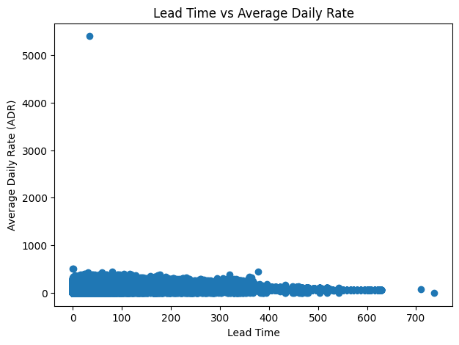
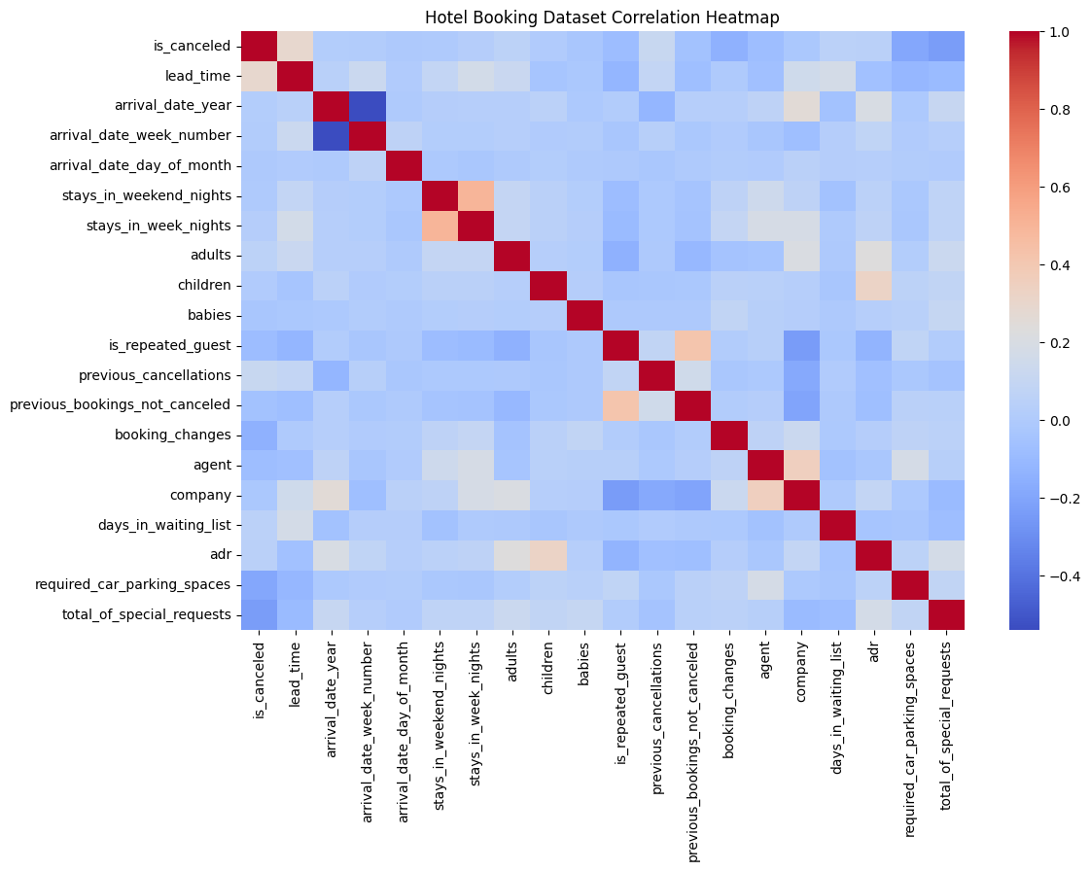

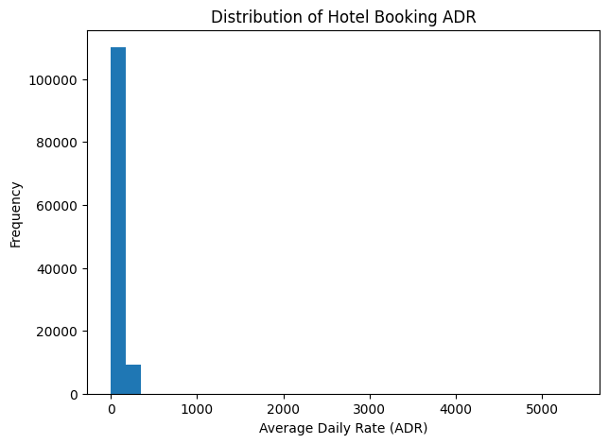

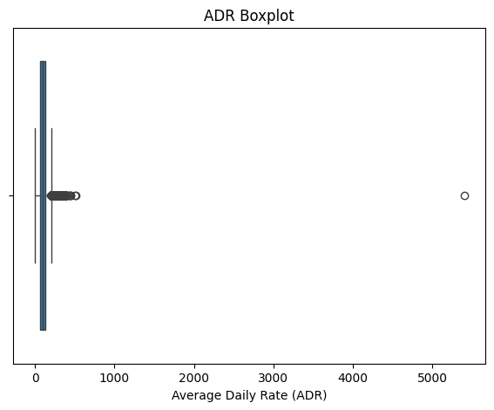

Market Segment Counts
market_segment
Online TA 56477
Offline TA/TO 24219
Groups 19811
Direct 12606
Corporate 5295
Complementary 743
Aviation 237
Undefined 2
Name: count, dtype: int64

Unique Hotels
['Resort Hotel' 'City Hotel']

Unique Market Segments
['Direct' 'Corporate' 'Online TA' 'Offline TA/TO' 'Complementary' 'Groups'
'Undefined' 'Aviation']

Unique Customer Types
['Transient' 'Contract' 'Transient-Party' 'Group']

Top 10 Countries by Number of Bookings
country
PRT 48590
GBR 12129
FRA 10415
ESP 8568
DEU 7287
ITA 3766
IRL 3375
BEL 2342
BRA 2224
NLD 2104
Name: count, dtype: int64

Number of Bookings by Year
arrival_date_year
2015 21996
2016 56707
2017 40687
Name: count, dtype: int64

Top 10 Countries by Canceled Bookings
country
PRT 27519
GBR 2453
ESP 2177
FRA 1934
ITA 1333
DEU 1218
IRL 832
BRA 830
USA 501
BEL 474
dtype: int64

Most Common Market Segments
market_segment
Online TA 56477
Offline TA/TO 24219
Groups 19811
Direct 12606
Corporate 5295
Complementary 743
Aviation 237
Undefined 2
Name: count, dtype: int64

CSV, Excel and JSON files exported successfully.

==============================================
EXPERIMENT COMPLETED SUCCESSFULLY
==============================================
Dataset Shape : (119390, 32)
Missing Values : 129425
Total Bookings : 119390
Total Canceled Bookings : 44224
Average ADR : 101.83112153446686
Number of Countries : 177
Number of Market Segments : 8
Number of Customer Types : 4
Correlation Matrix Generated
==============================================

RESULT

